Supervised Learning Models to Predict the Yield Curve
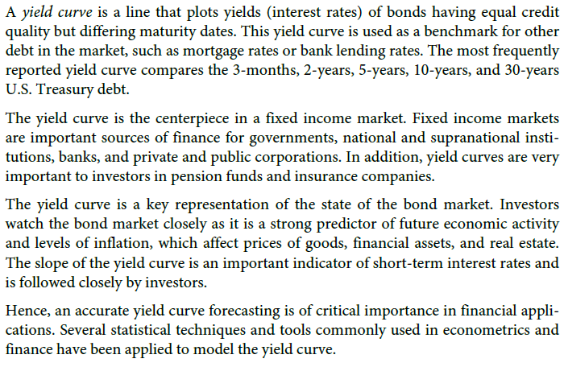

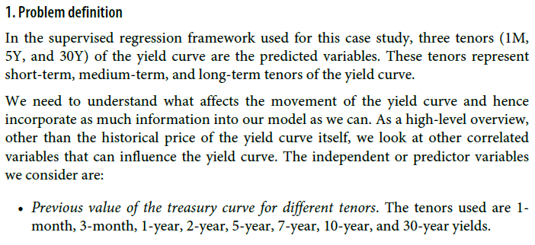
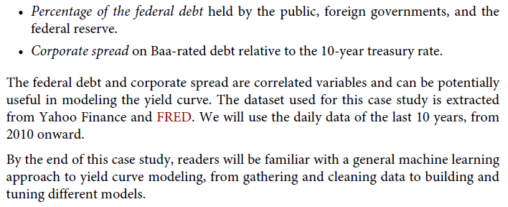
NOTE: Try your creativity and knowledge to make your project innovative

**********NO AI Generated Content***************
**********You can take online help for coding********

Tasks
- Connect to Yahoo finance and extract the dataset
- Perform EDA
- Perform regression using the frameworks
XGBoost, Keras, Pytorch with fastai, Pytorch with Tabnet, Pytorch with
Lightning Flash
- Report comparison based on
Simplicity
Transparency
Efficacy
Also report comparison for metrics like RMSE, R², MAE etc
- Report: Generate report including –
Introduction
Methodology
EDA
Results
Conclusion/Summary
- Presentation:
Make a PPT including above and prepare for VIVA.
Check-in the code in a github repository and share for viva

